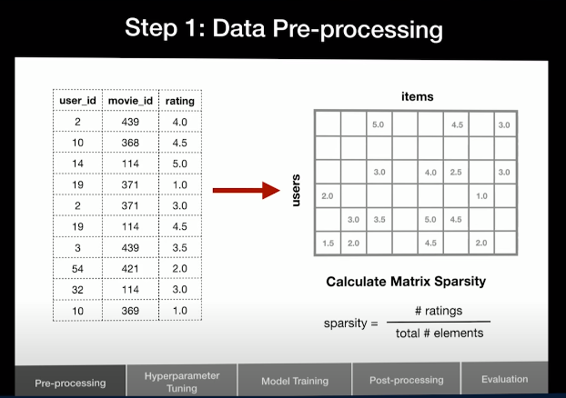

If too many empty cells: collaborative filtering not useful.

—------------------------------------------------------------------------------

Eg.2. Which of the two unwatched movies should be recommended?

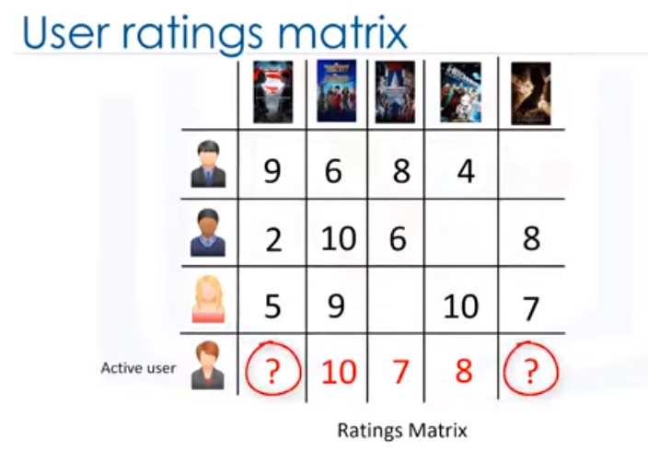

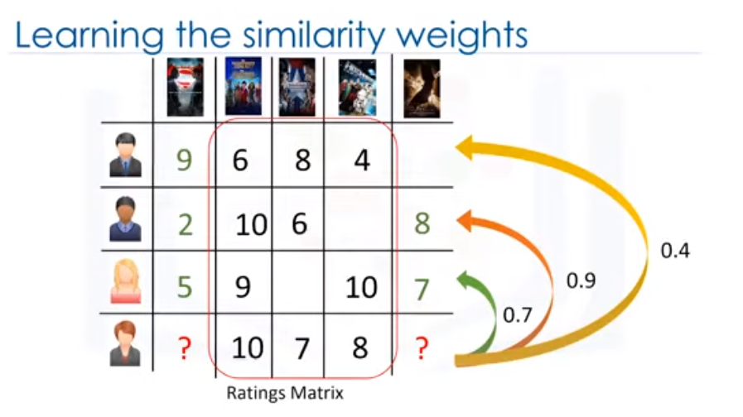

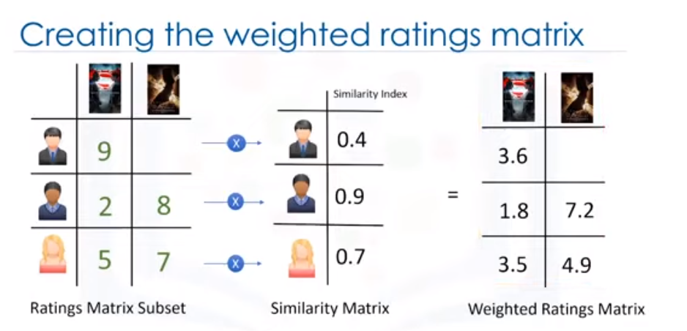

Multiply both things to get a weighted ratings matrix.

This gives importance to ratings of people who are similar to my active user (the one who needs recommendations)

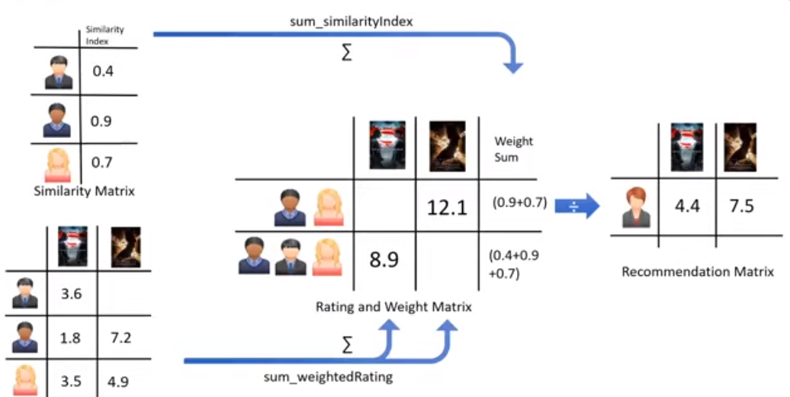

1. User based collaborative filtering

user 1 likes item 1,3,4

user 2 likes item 2

user 3 likes item 3,4

conclusions:

(user 1 and user 3) both like item 3 and item 4

user 1 and user 3 : similar users : neighbours

recommend item 1 to user 3

.........................................

2. item based collaborative filtering

user 1 likes item 1,3,2

user 2 likes item 1,3

user 3 likes item 3,4

conclusions:

user 1 and user 2 both like (item 1 and item 3)

item 1 and item 3 : being liked tg : neighbours

recommend item 1 to user 3

……………………………………………….



